

Student’s Guide

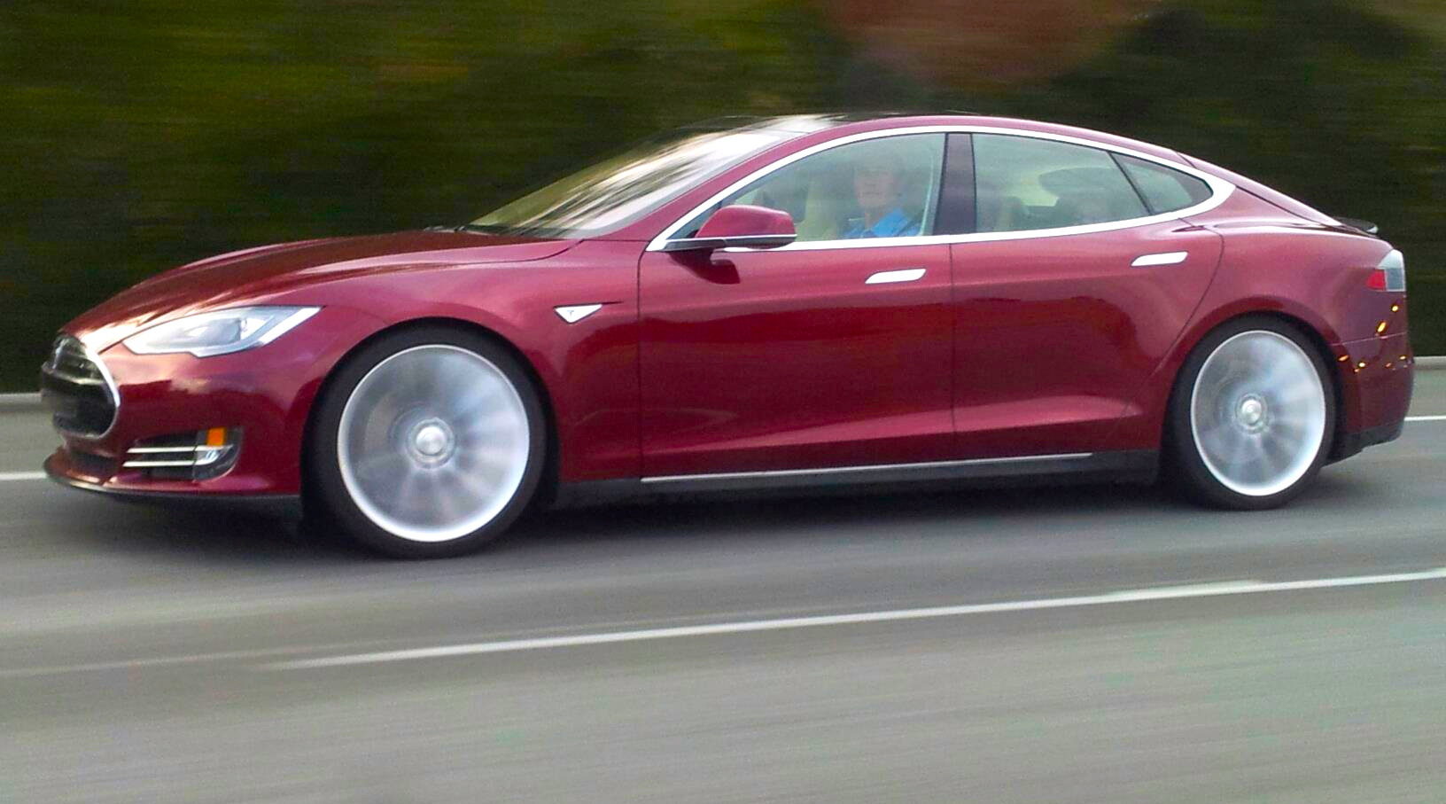The Electric

The Model S electric car by Tesla Motors, unveiled in 2009, offers competitive performance. With its Li-ion battery, it has 500 km of independence and can drive at 250 km/h. Best invention of 2012, according to Time Magazine.

Source: Tesla Model S on Hwy 280 California driven by   
Steve Jurvetson, who received the first production vehicle.   
Steve Jurvetson/Camilo. ([Wikimedia](https://commons.wikimedia.org/wiki/File:Tesla_Model_S_Sightings.jpg))

Car

When the technology

of the future draws on

ideas of the past

Olivier Tardif-Paradis

Alexandre April

Mathieu Riopel

Cégep Garneau



Past solutions meet future needs

Context

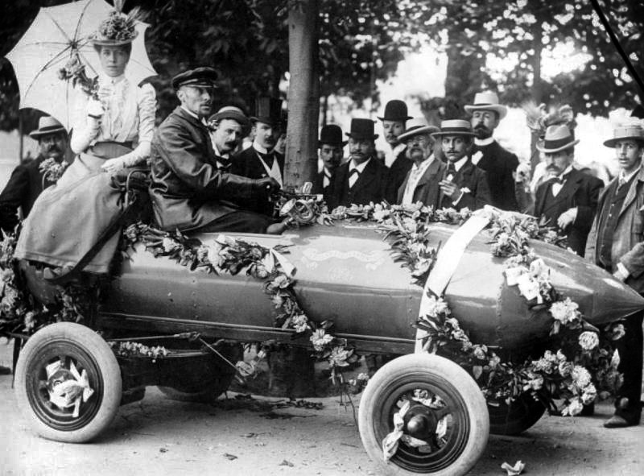The decline of planetary energy sources, climate change and the increase in diseases related to atmospheric pollution are all effects of a common cause: the combustion of fossil fuels. These effects are devastating, because “air pollution […] in 2012 was responsible for 7 million deaths – one in eight of all deaths worldwide.”[1] A significant portion of this combustion is for transportation, but there have been alternatives to fossil-fuelled transportation for many years. For example, the electric car was developed at the end of the 19th century, even before combustion engine vehicles. At that time, electric cars that offered very competitive performance were being built. On April 29, 1899, a Belgian engineer and car racer was the first to exceed 100 km/h in an automobile. He achieved this exploit with an electric vehicle of his own design that he called the “Jamais Contente” (never content). Despite the successes of the 1890s, the electric car that was made for the market, which did not perform up to Jenatzy’s car’s standard, was unable to resist the rise of the gas-powered automobile that followed it. The electric vehicles did have a number of disadvantages, including:

Fig. 1 – Camille Jenatzy (1868-1913) aboard the Jamais Contente at a parade celebrating his record speed (106 km/h).

Source : Driver Camille Jenatzy in Jamais Contente : first automobile to reach 100 km/h in 1899. ([Wikimedia](https://commons.wikimedia.org/wiki/File:Jamais_contente_parade.jpg))

* Limited independence of just 100 km
* Maximum speed of 40 km/h
* Battery recharging time of several hours
* Higher purchase price than gas-powered automobiles

Resource depletion, climate change and air pollution were not selection criteria for consumers in those days. Today, the priorities of many consumers have changed, and technology – including electric battery technology – has advanced. In today’s world, the modern electric car is of increasing interest to drivers. Future car consumers will have to draw inspiration from the achievements of the past. Electric automobiles are already on our streets, as they were in the 19th century. It is just a matter of time before the electric car is the preferred driving option for Quebecers, and society will be a double winner. For one thing, Québec already produces enough electric energy to be electricity independent, and for another, the province will no longer have to spend so much importing the oil we are in the habit of using.

What are the capacities of this kind of electric vehicle? What are the basic principles of the electric engine? How can we optimize the performance of this type of engine? To launch the discussion and answer these questions, you will be asked to analyse a prototype of an electric engine made to propel a small vehicle. First of all, you will have to calculate the performance of an electric engine. Then you will have to optimize the electric circuit that generates the electric engine’s torque at start-up and in motion.

Three-Step Cycle

List all the relevant information you have gathered from the problem. Based on this information, state what you need to know to solve the problem. As new information comes in, you will want to summarize and update the relevant information you have gathered and ask new questions.

List the following:

|  |  |  |
| --- | --- | --- |
| **What we know** | **What we need to know** | **Summary** |
|  |  |  |

1. Characteristics of the engine at start-up

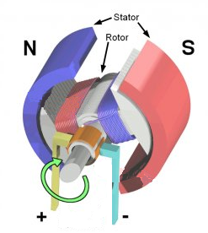An electric engine is made up of a rotor (the part that rotates) and a stator (the part that is static). Building an electric engine is simpler than building a combustion engine, because the electric engine only has one mobile component (the revolving rotor) while a combustion engine has dozens or even a hundred moving parts. Consider that a rotor is comprised of a long rectangular frame *a* = 2.6 cm wide and *b*= 8.7 cm long. To construct the rotor’s bobbin with the highest number of turns on the frame, we have a wire with a total length of *L* = 7.25 m and a linear resistance of 52.95  /km. For simplicity’s sake, we use a single winding to make the rotor. To construct the stator, we use two flat neodymium magnets which create, between their opposing poles, an assumed constant and uniform magnetic field with a modulus of *B* = 0.08 T in the area where the rotor is seated. Two real batteries, each with an EMF of ** = 9 V and an internal resistance of *r*= 0.5 , provide energy to the electric engine. The engine is directly connected to the front wheels of the vehicle (forward traction). The torque exerted by the electric engine therefore corresponds to the traction torque that permits the acceleration of the vehicle.

Fig. 2 – Electric engine with a single bobbin. The stator creates a constant and uniform magnetic field (north-south) and the rotor turns when an electric current runs through the winding.

Source: Illustration of a simple electric motor. Wapcaplet. ([Wikimedia](https://commons.wikimedia.org/wiki/File:Electric_motor_cycle_2.png#filelinks)). This work is licenced under a [Creative Commons Attribution - ShareAlike 3.0 Unpurported](http://creativecommons.org/licenses/by-sa/3.0/deed.en).

Questions: Zero angular velocity engine

1. What mathematical equation can be used to determine the modulus of the force *F* exerted on a wire with an electric current running through it inside a uniform and constant magnetic field *B*?
2. When the engine is not yet turning, what is the maximum value of the current that can run through it thanks to the two batteries at our disposal? To achieve this maximum current, should the batteries be placed in series or in parallel?
3. At the angle shown in Figure 3, what are the size and direction of the force exerted on each of sections 1, 2, 3 and 4 of the winding? Qualitatively draw each of the forces in the diagram.

Fig. 3 – Winding of the rotor in a constant and uniform magnetic field .   
The angle between the winding axis and the magnetic field is θ = 30º.

Source: Mathieu Riopel

1. What is the torque acting *B* on each of sections 1, 2, 3, 4 of the winding shown in Figure 3?
2. How should the rotor be oriented in relationship to the stator to exert the maximum magnetic torque on the frame?
3. What mathematical equation can be used to find the value of the torque *B* exerted on the bobbin of *N* turns in a constant and uniform magnetic force *B*? What is the maximum value of the torque?

2. Characteristics of the vehicle in motion

We have the same type of electric engine that was studied in the previous test. The analysis of the engine in rotation is more complicated than the last analysis. The electric circuit is influenced by the counter-electromotive force (counter-EMF) generated by a variation in the magnetic flux through the rotor. Furthermore, we have to ensure the proper functioning of the brushes and the commutators, which are indispensable to the rotation of the engine. For the following questions, assume that the angular velocity of the engine is = 200 RPM.

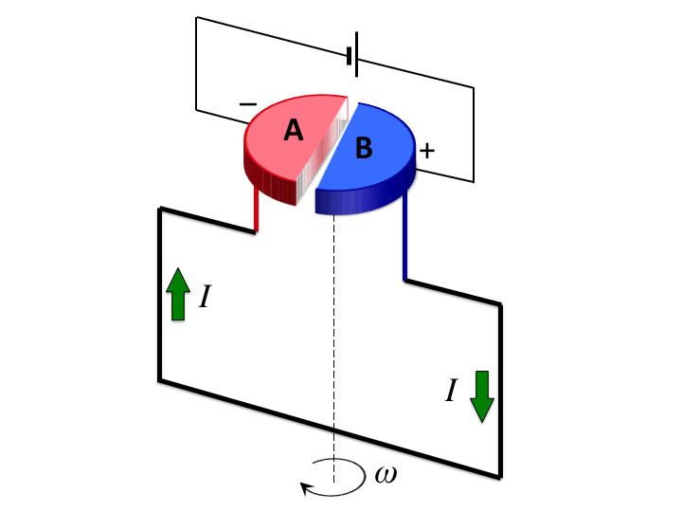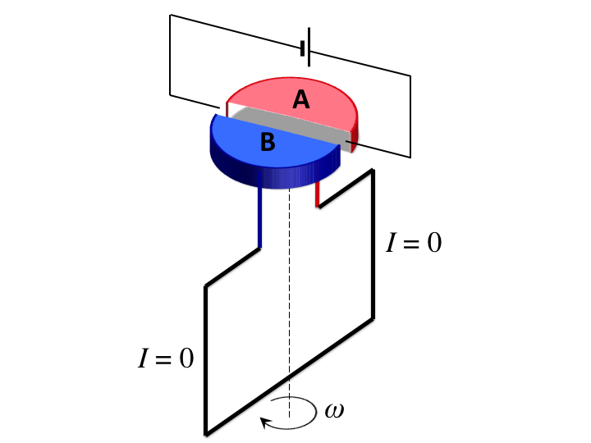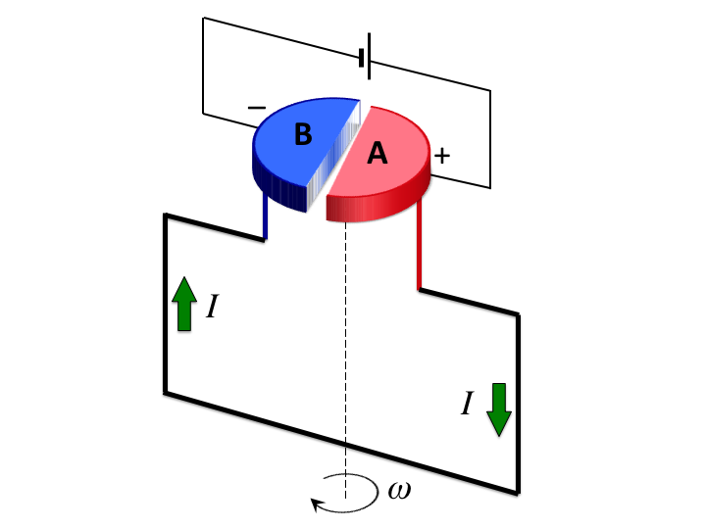



(a) (b) (c)

Fig. 4 – (a) The brushes are in contact with commutators A and B, (b) the brushes are no longer in contact with the commutators, (c) the brushes are in contact with the opposite commutators from the ones in (a).

Source : Alexandre April

Questions – engine in rotation

1. Explain what is meant by counter-electromotive force (counter-EMF). What mathematical equation can be used to find the value of the counter-electromotive force for a bobbin?
2. What is magnetic flux? Name three situations in which the magnetic flux can be varied.
3. What is the effect of the commutators and the brushes on the rotation of the engine? Would it be possible to make the engine turn without these parts? Justify your answer by referring to magnetic forces that you draw on Figures 4(a) to 4(c).
4. In reference to the rotor, the EMF of the batteries changes periodically as shown in Figure 5a). From Figures 5b), 5c), 5d) and 5e), choose the one that shows the progress of the counter-EMF in reference to the rotor. Then, on Figure 5a), draw the function chosen for the counter-EMF. At the same time, find the amplitude of the counter-EMF.



Fig. 5a) **–** In reference to the rotor, the electromotive force of the batteries changes over an interval of time that corresponds to two cycles of the rotor.

Source : Alexandre April

Choice of function representing the counter-EMF in reference to the rotor:

|  |  |  |
| --- | --- | --- |
| Fig. 5b) |  | Fig. 5c) |
| Fig. 5d) |  | Fig. 5e) |

1. Now, on the same graph, draw the EMF of all the batteries and the counter-EMF of the engine in reference to the batteries.

MacBook Air:Alexandre : Cégep: CCDMD:CCDMD physique 2015 AA, MR et OTP:OTP - Voiture électrique:Schémas:graphique 5f.pdf

Fig. 6

1. When the counter-EMF achieves its maximum value, which configuration (series or parallel) should we choose for the two batteries, so that the current running through the rotor is as high as possible?
2. What is the maximum value of the magnetic torque acting on the rotor?

*Note:* *A more in-depth analysis of the problem shows that the torque achieves its maximum value when the surface vector* * of the rotor and the magnetic field  of the stator are perpendicular to each other.*

1. WORLD HEALTH ORGANIZATION. *WHO calls for stronger action on climate-related health risks***,** [Online], [http://www.who.int/mediacentre/news/releases/2014/climate-health-risks-action/en/] (Viewed December 7, 2015).