Student’s Guide

Bungee Jumping

Camil Cyr
Collège de Maisonneuve

Adaptated by: Caroline Viger
John Abbott College

Bungee Jumping

Context

An outdoor recreational centre in the Laurentians would like to attract more tourists by offering bungee jumps. How exciting! The owner of the site has asked you to calculate the parameters of the elastic bungee cord that will be attached to the courageous jumpers. You are an engineer and accept the contract with great pleasure.

The owner explains what he needs by scribbling on a piece of paper (refer to the diagram):

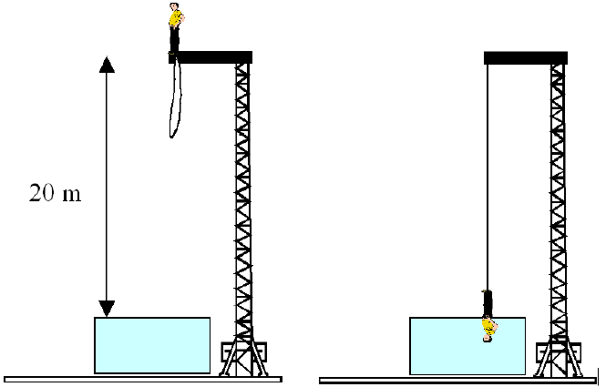
20 m

“The jumper will dive into a pool filled to the rim with water. An elastic bungee cord will be attached to the jumper’s feet.
- The distance between the water surface and the diving board is 20 m.
- The bungee cord is 12 m long in its relaxed state (not stretched).
- The bungee cord must be such that when it is fully stretched (refer to the diagram), the jumper will penetrate the water up to his waist (which is approximately half his height) before being pulled back upwards.

I need your recommendations with regard to this project. How does it compare to other bungee jumping locations (particularly across Canada)? What elastic constant do we need for the bungee cord? Finally, would you be able to tell me if such a jump would be safe right now?”

Three-Step Cycle

List all the revelant information you have gathered from the problem. Based on this information, state what you need to know to solve the problem. As new information comes in, you will want to summarize and update the relevant information you have gathered and ask new questions.

List the Following:

What We Know | What We Need to Know | Summary

Questions

- What should you look for in order to answer the owner’s questions? Make at least two recommendations.

- Draw up a list of known and unknown quantities. Can the unknown quantities be researched or estimated? Add the quantities that you have found or estimated to your list. Clearly indicate your sources.

- How will you take into account the fact that human beings (as well as the bungee cord) are not particles? Under what conditions would you treat them as particles?

- Make a detailed diagram of the situation before and after the jump and indicate all known quantities.

